**USING SAILWAVE FOR RACE RESULTS - UTLSC**

Version 4 Feb 2017

**BEFORE THE RACE:**

**Put out a signing in sheet for competitors to sign in for the race.**

**Write up the entrants on to the paper race sheet and fill all the details – OOD and safety boat names, boat helm crew sail number as usual.**

**(As the races progresses fill in details as usual – tick if starter, and position at the end of each lap and finishing time.)**

**The computer:**

1) Open the computer and log in to OOD with password **tamar**

2) On the desktop, you'll find various folders, each for a race series; open the folder for that morning or afternoon's race series with a double left click of the mouse.

3) Within the folder, there will be separate files for each race in that race series; open the race sheet for race with double left click on the file for the race whose details you want to input .You will see this screen:

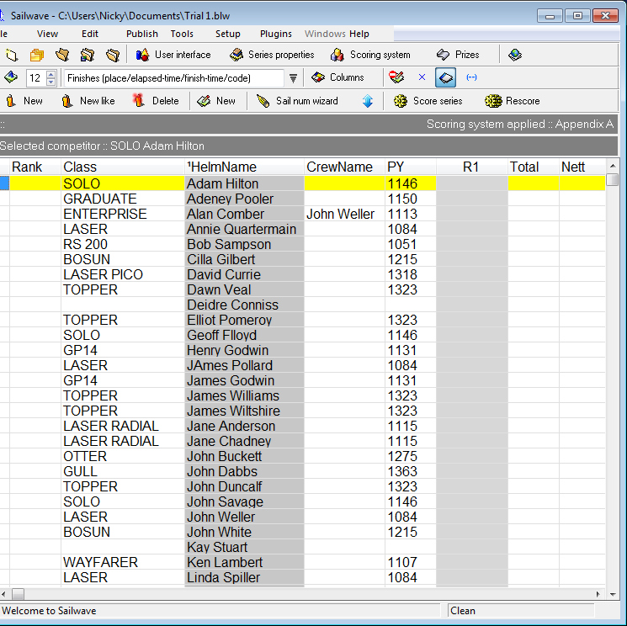This sheet will contain the names of all current racing club members, together with the boat they most often race and, in the third column, the PY for that class of boat.

4)**When everyone is signed in on the signing in sheet** The next stage is to remove the names of everybody ***not*** sailing, so that you are left with just those helms (and their boats) who have signed up to do the race the OOD and safety boat crew.

*(Although it may seem counter-intuitive, early tests have shown that the fastest and least-error-prone way to do this is to start with the list of all helms and then delete those* ***not*** *sailing, rather than starting with a blank list and manually typing all the helms & crews and boat names in. (Note that the list of those sailing should also include the names of those doing OOD or Safety boat))*

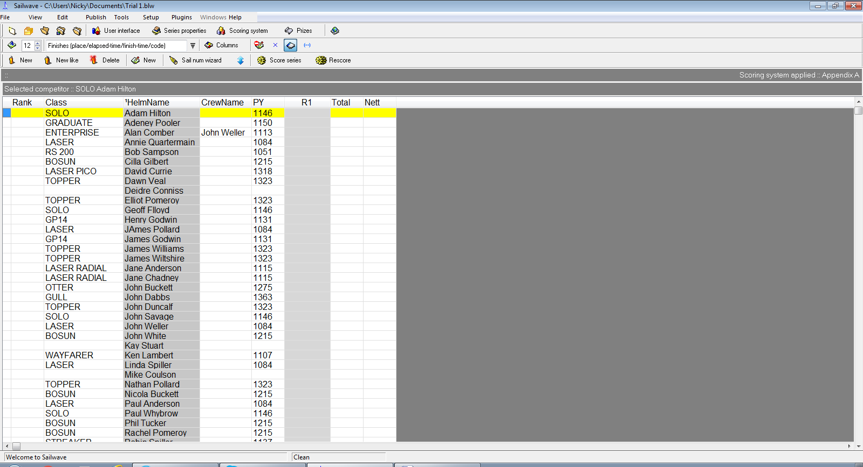To remove anyone not sailing left click in the Delete button on the Menu bar.

This will open a new window on top of the initial Sailwave screen, as shown below:

*Note that the list of competitors is sorted by* ***first name***, *and not by surname, as you might have expected* .

5) Click on all those names that you wish to **DELETE** because they are not racing, individually in turn**. All those names that are to be deleted will be highlighted in blue.** If you have made a mistake and inadvertently clicked on the name of someone who ***is*** actually racing, click on their name a second time, which will clear the blue highlight.

The screen on the below shows the window before the process of deleting non-racers has started.

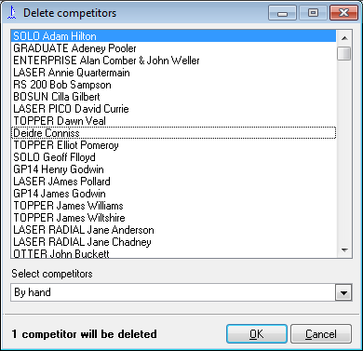

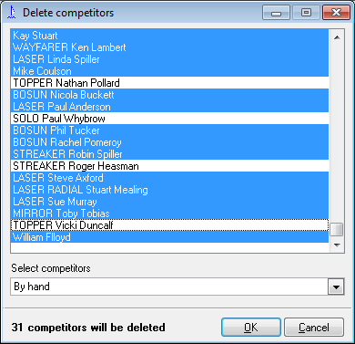The screen on the left shows a race in which most of the names are going to be deleted; on the part of the window that is shown, only Nathan, Paul, Roger and Vicki are shown to be racing - though if you were to scroll back up through the window, there will be others. When the only those entering the race, doing OOD or safety boat are NOT highlighted press **Enter** or click **OK.**

A new window confirming you wish to delete these competitors will appear. If you are still happy with the selection press Enter or use the mouse to click **Yes**.

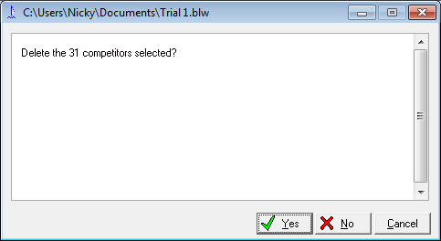

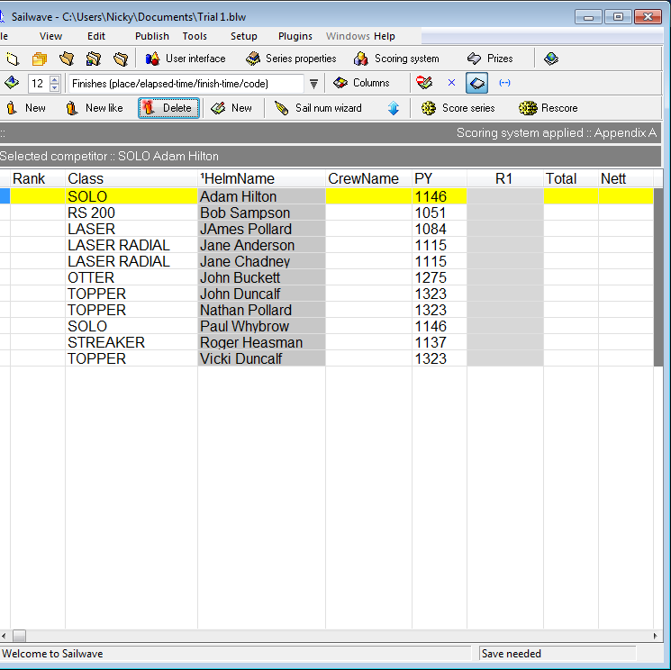

6) The race sheet will now look like this with only those entering the race, doing OOD or safety boat listed.

**If you have deleted a competitor by mistake or there is an entrant not on the initial list (for example, a new member of a guest helm),** you can now either re enter them or enter them by selecting new on the top menu bar.

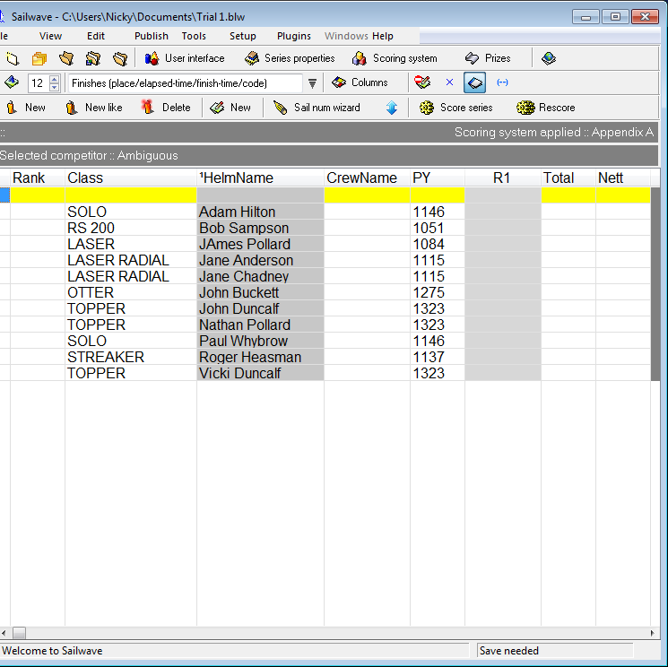

A new line will appear in the sheet highlighted in blue and yellow:

7) Double click in the Helm Name and the window below will appear.

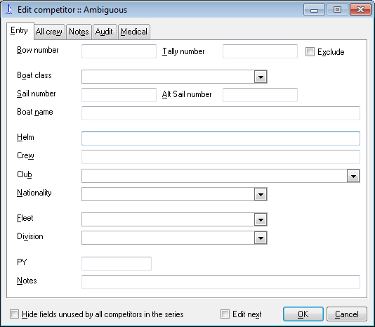

First click in the helm window and enter the name missing or needing adding.

Add a name to the crew window if appropriate.

8)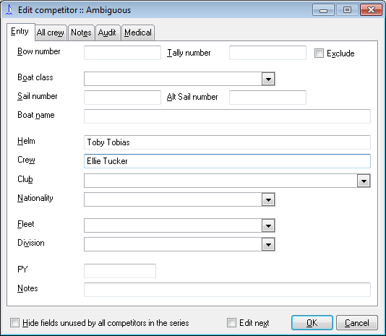 Then click on the arrow of the Boat Class drop down Menu and **select the correct boat** and then click **OK** or press **Enter**. The PY will automatically appear on the race sheet together with boat class crew and helm information.

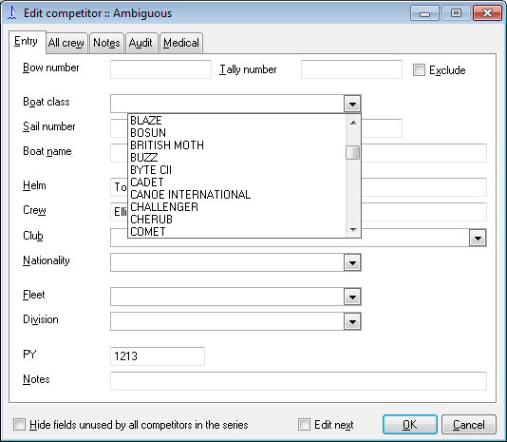

9) Now check the boat class assigned to each helm are correct.

**If any boat class entry is incorrect double or empty, click on the helm name to open the window and edit the boat class as above.** Then click **OK** or press **enter**. Do this for each boat class that is not correct.

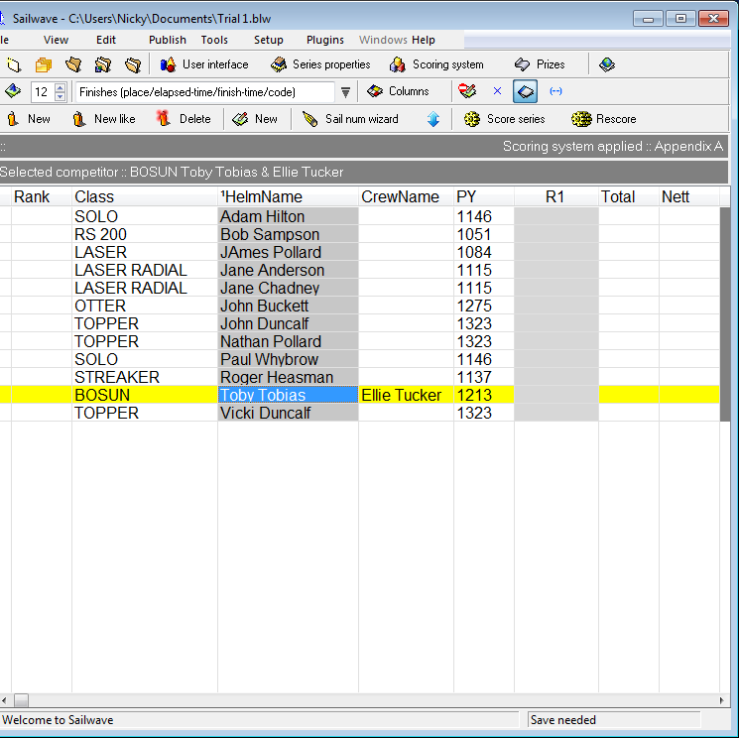

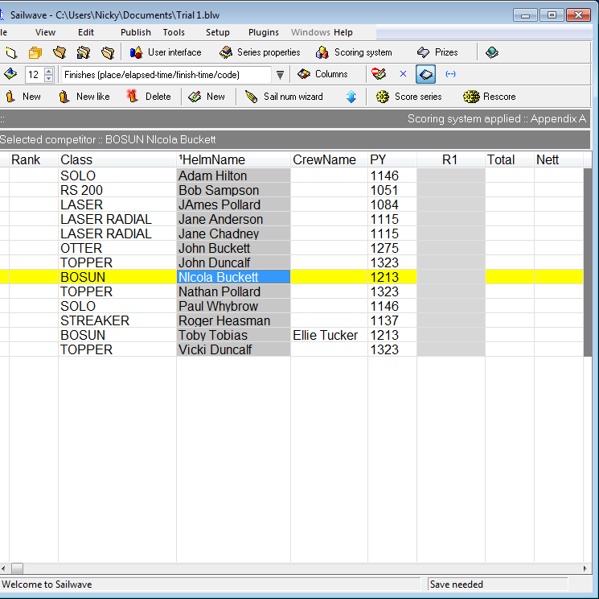When all helms are entered with the correct boat class**, check that the OOD and Safety boat crew are entered** with a boat class they usually sail. Do this in the same way as adding a competitor above. Enter safety boat as OOD

Eg. Nicola Buckett OOD

**The race sheet is now prepared so save** so that it is ready to add the timings for the results later.

**To save** select File with the mouse to get the drop down menu and click save series.

*You have now done everything that you need to do before the start of the race.*

**DURING THE RACE:**

10) Take the boat times as usual for the race and record them on the **paper** race sheet. ( *Don't try to record the race times directly into the Sailwave package - always do them on paper first, so that you've got a backup.)*

**AFTER THE RACE:**

11) After the race, read off the finish times for each boat from the paper race sheet and enter them onto the Sailwave package, as shown below:

Using the cursor, *double click on the R1 column* of the competitor you wish to input a finish time for.

eg the window immediately below shows clicking on the R1 column for Adam’s result:

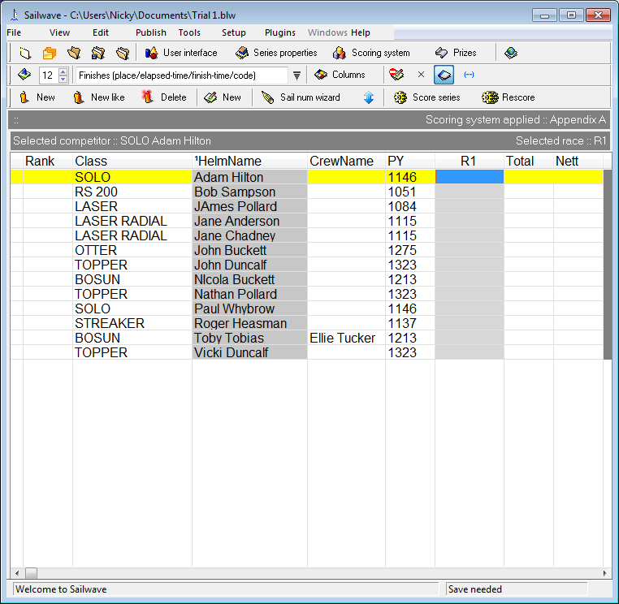

12) A new window will appear, as shown below: put the cursor on the start time button and left click.

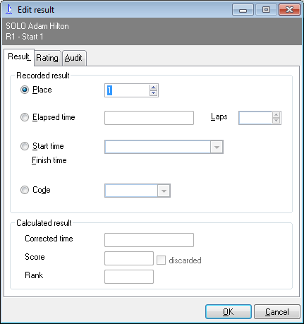

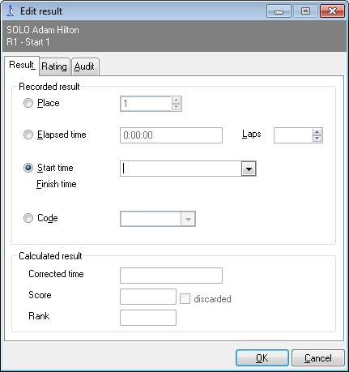13) Now enter the start time of the race in the box in the format 12.00.00

14) Then click just below the start time box to enter Adam’s finish time 13.10.15 (*this is initially confusing, because a big/feature in the Sailwave package means that there doesn't appear to be a box to type into; nevertheless, just type underneath 'Start time' box above - and it will work....)*

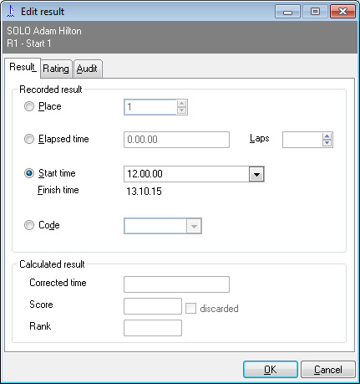**Check the result is correct and press enter or use the mouse to click OK** and the result will be entered on the race sheet.

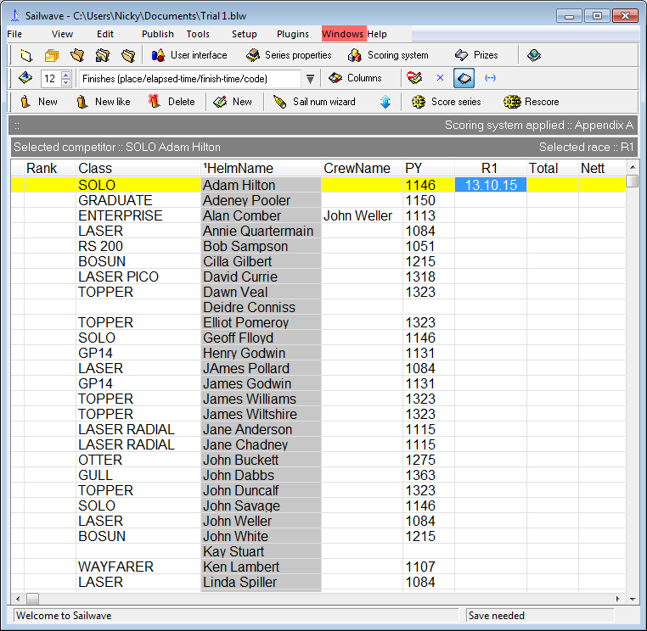

15) Repeat this stage for each of the competitors in the race in turn. You will find the start time is already entered after the first result is entered.

16) There is an additional stage needed to record any competitors who retire - and also to enter details of the people who are being OOD/safety boat crews: double click on the Race 1 column rectangle line with their name Eg Nicola Buckett OOD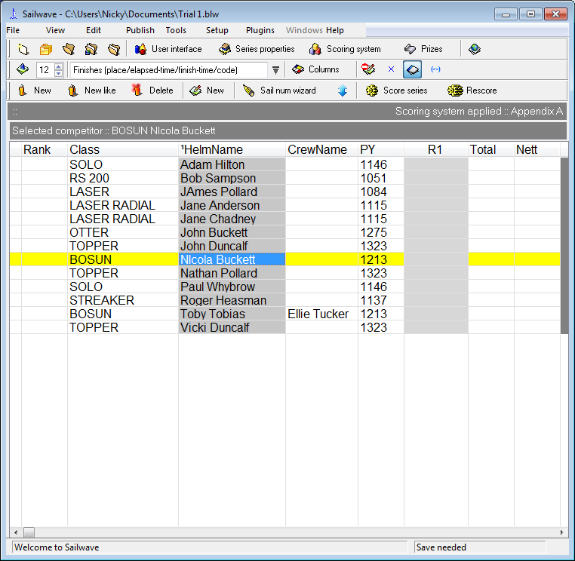

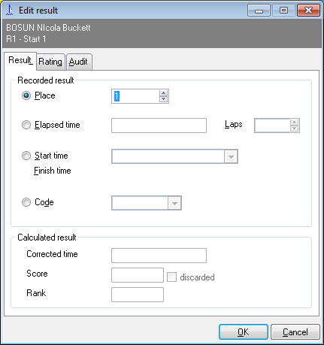17) The window below will appear again.

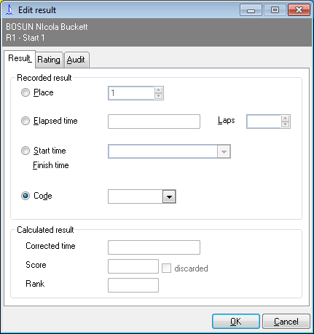Now click on the 'Code button.

The cursor will appear in the Code box. Now click on the arrow to get the drop down menu.

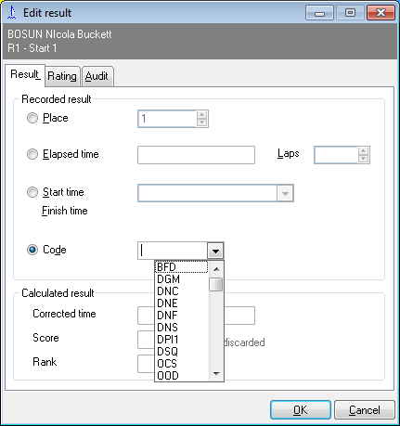

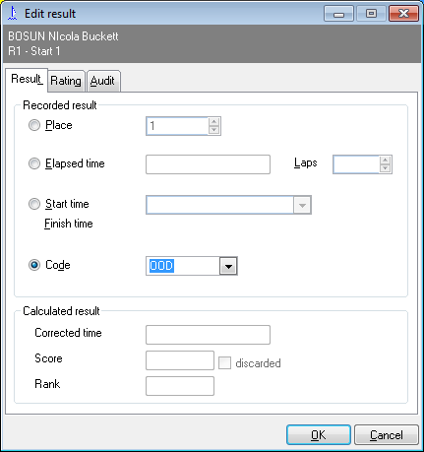18) Scroll down and select OOD. Press Enter / click OK

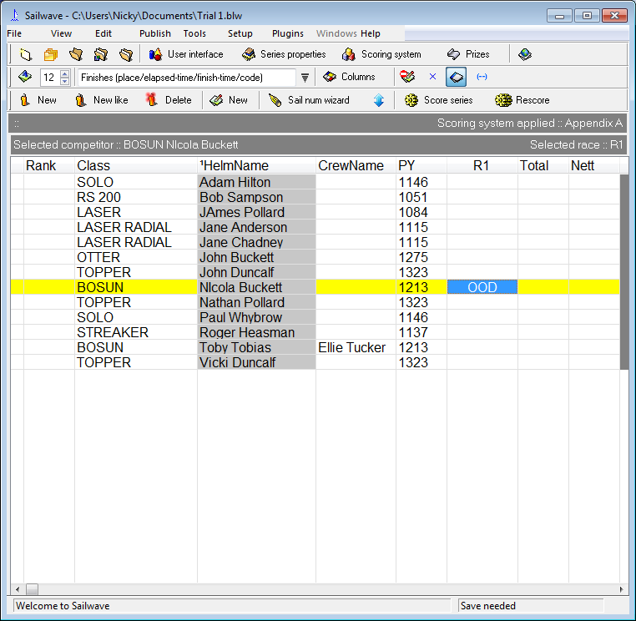

19**) If someone has retired**, repeat the above for their R1 column cell and select **RET** from the **Code** drop down menu

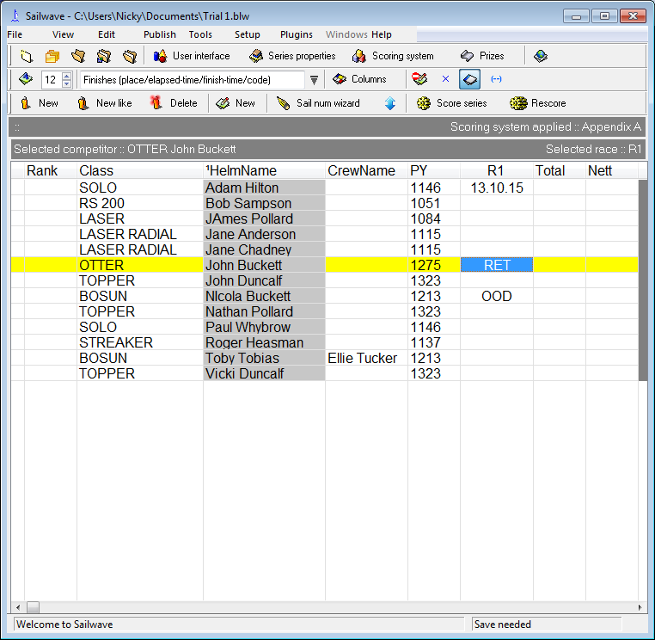

20**) Now all the results are complete**, click on **'Score series'** at the top of the original Sailwave window, as seen below

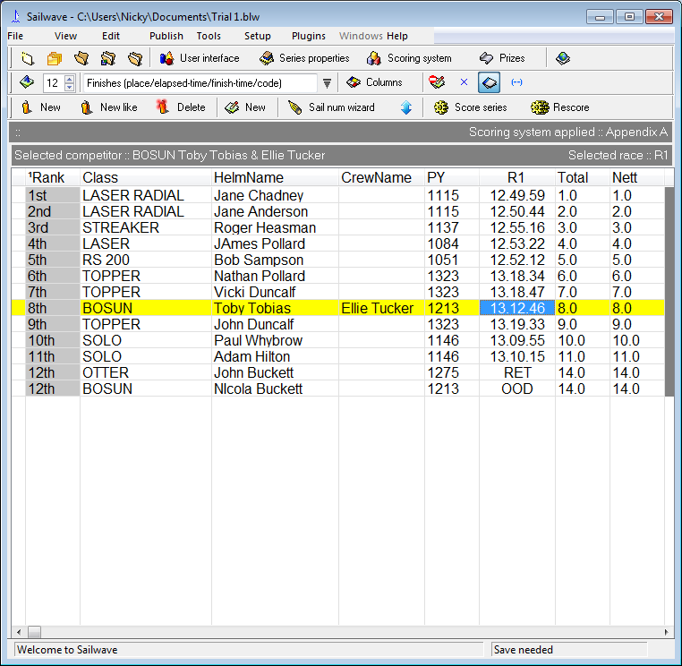

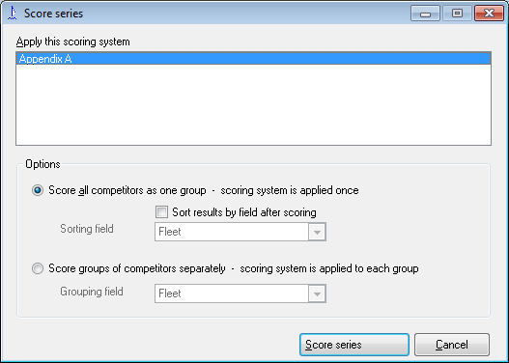Now this window will appear:

Press **enter** or click on **score series**.

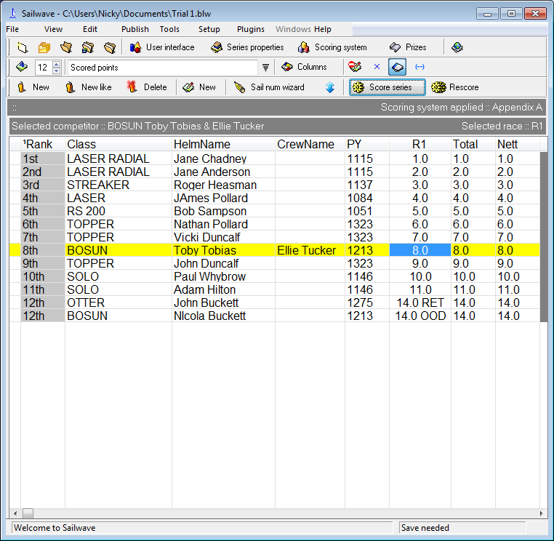

The final results can be read off the Race column **R1** and entered on to the paper race sheet and announced!

**NOW save the file** by clicking on File and selecting “**save series”** on the file drop down menu top left hand corner..

IF YOU ARE ASKED TO SHOW CORRECTED TIMES AS SOME PEOPLE LIKE TO SEE THE CORRECTED TIME DIFFERENCES CLICK ON THE DROP DOWN ARROW ON THE SCORED POINTS MENU AND SELECT CORRECTED TIMES AND THESE WILL APPEAR IN THE RACE COLUMN INSTEAD OF PLACINGS. RESELECT SCORED POINTS BEFORE SAVING PROGRAMME.

Thank - you the file can now be closed by clicking on the cross in the top right corner.



**THANK-YOU!**